 | DETAILS
STUDENT | MASHAO KB
STUDENT NUMBER | 45413657
PROJECT ID | CMPG325-2026-052
CLIENT ID | CLI-052
ASSIGNED ORGANIZATION | TSHIAMO BOUTIQUE HOTEL(KLERKSDORP)
INDUSTRY | HOSPITALITY
ADDRESS BLOCK | 172.30.28.0/23
TECHNICAL CHALLENGE | STP (LOOP PREVENTION AND ROOT DESIGN)
DESIGN CONSTRAINT | FINANCE DEPARTMENT MUST BE ISOLATED FROM ALL GENERAL USERS
CHANGE REQUEST | CR4 – NEW APPLICATION/FILE SERVER, REACHABLE BY AUTHORISED DEPARTMENTS ONLY

- CLIENT REQUIREMENTS

  - Client Background
Tshiamo Boutique Hotel is a small hospitality business in Klerksdorp. The hotel requires a network that supports daily operations across reception, housekeeping, food and beverage, finance and management, while providing internet access to guests. The design must protect financial data and control access to a newly installed application/file server.
  - Departments and functional areas
•Management / IT
Administration of the network and hotel systems; requires access to all resources.

•Front desk/reception
Guest check-in and check-out, reservations; requires access to the application/file server.

•Finance
Accounts, payroll and billing; must be isolated from all general users.

•Housekeeping
Room status terminals; general connectivity only.

•Food & beverage
Restaurant and kitchen point-of-sale terminals; general connectivity only.

•Guest Wi-Fi
Hotel guests; internet access only, no access to internal resources.

  - Functional requirements

•Provide LAN connectivity and appropriate network services to every department.
•Provide inter-VLAN routing so that permitted departments can exchange data.
•Support a newly deployed application/file server in line with change request CR4.
•Provide guest Wi-Fi that has no route to any internal department resource.
•Provide redundant links between the distribution and access layers for resilience.
•Use the assigned addressing block 172.30.28.0/23 as the basis of all addressing.
•Produce a working, testable Cisco Packet Tracer implementation.
  - Design constraint
The finance department needs to be kept apart from everyone else.
It is understood that this is a two-layer requirement. Initially, Finance is assigned to a dedicated VLAN (VLAN 30) on a dedicated access switch. Only the Finance and Management VLANs are allowed on the trunk lines that serve that switch. Second, communication between VLAN 30 and all other user VLANs is prohibited in both directions by an enhanced access control list implemented at the core switch. Access for administrative support is still available to management and IT; this is a purposeful and documented exemption rather than a mistake.
  - Client change request — CR4
Only authorized departments must be able to access the newly deployed application/file server
In order to control access from a single location, the server is located in a dedicated server VLAN (VLAN 60) as opposed to a user VLAN. The server subnet is accessible to Management/IT (VLAN 10) and Front Desk (VLAN 20) but not to Housekeeping (VLAN 40), Food & Beverage (VLAN 50), or Guest Wi-Fi (VLAN 70) due to an access control list at the core switch. Since reservations and visitor records are the server's main business uses, the front desk is regarded as an authorized department.
  - Assigned networking challenge — STP
The task at hand is spanning tree protocol: root bridge design and loop prevention. Because there is nothing for STP to demonstrate without a physical loop, redundant links have been purposefully incorporated into the topology. The two distribution switches are trunked to the core and to each other, creating multiple Layer 2 loops, and each access switch is dual-homed to both distribution switches.
Root bridge design: the core switch has priority 4096 and is set up as the root bridge. Placing the root there causes the spanning tree to converge toward the point where traffic actually flows, and the ports that STP blocks are actually redundant paths rather than paths in active use because the core aggregates all inter-VLAN routing, the CR4 application/file server, and the guest access point. In order to take over as the root in the event that the core fails, DIST-SW1 is set up as a secondary root with priority 8192. DIST-SW2 continues to use 32768 as its default priority. Convergence is quicker than with traditional 802.1D thanks to the usage of Rapid PVST+, which keeps each VLAN's own spanning tree instance.
- PHYSICAL TOPOLOGY
For a site of this size, the network's three-tier hierarchical model—core, distribution, and access—is suitable since it keeps Layer 2 switching and routing and policy enforcement apart and provides a clear space for adding redundancy.
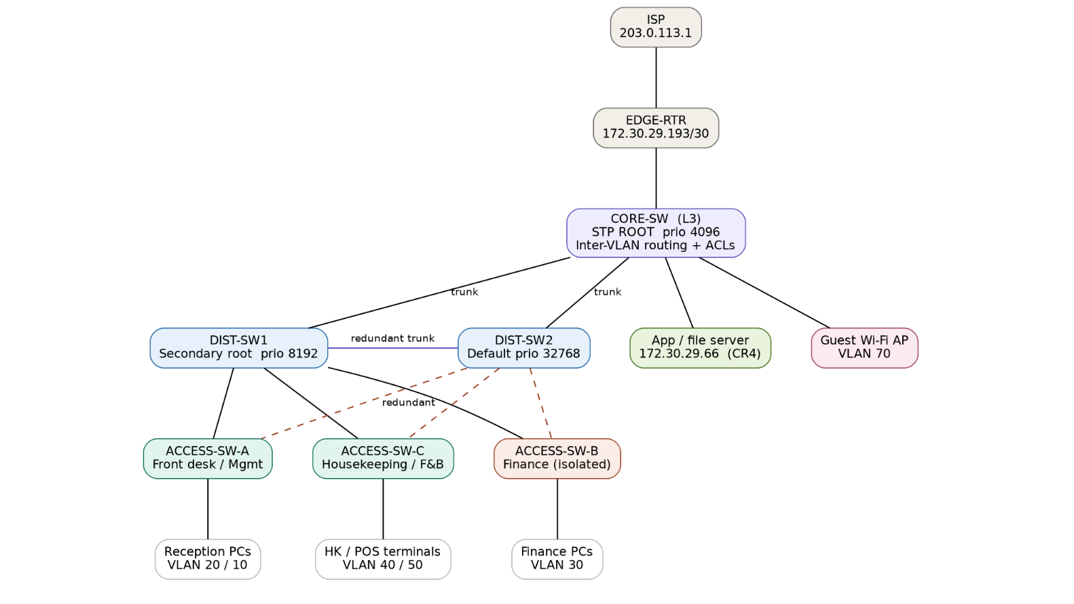
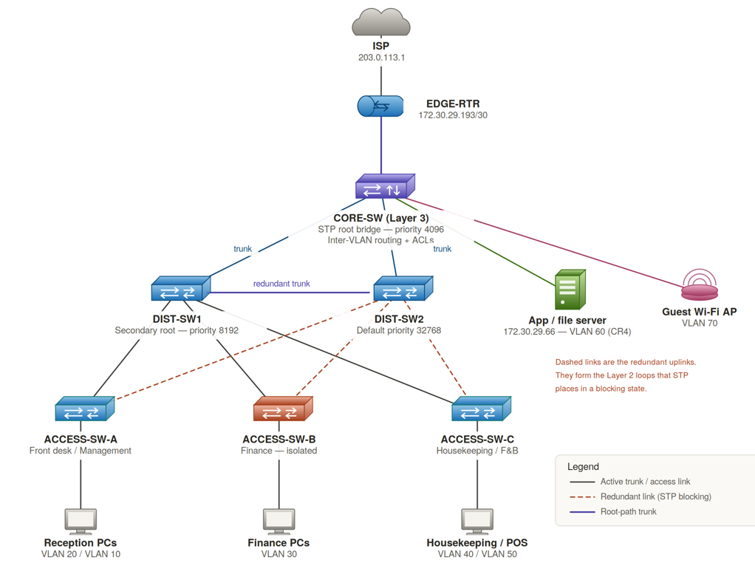
2.1 Device inventory
Device | Role | Management IP
EDGE-RTR | Edge router; ISP-facing, default route to internet | 172.30.29.193/30
CORE-SW | Layer 3 switch; inter-VLAN routing, ACL enforcement, STP root bridge | 172.30.29.194/30
DIST-SW1 | Distribution switch; STP secondary root | 172.30.28.2/26
DIST-SW2 | Distribution switch; default STP priority | 172.30.28.3/26
ACCESS-SW-A | Access switch; front desk and management | 172.30.28.4/26
ACCESS-SW-B | Access switch; Finance only (isolated) | 172.30.28.5/26
ACCESS-SW-C | Access switch; housekeeping and food & beverage | 172.30.28.6/26
App/file server | CR4 application and file server | 172.30.29.66/26
Guest Wi-Fi AP | Guest wireless access | VLAN 70
  - Cabling and redundancy
•A routed /30 link connects the edge router to the core switch.
•A trunk connects each distribution switch to the core switch.
•Direct trunking connects the two distribution switches to one another.
•Every access switch has two uplinks: one to DIST-SW1 and one to DIST-SW2.
•On access ports, the guest access point and application/file server are directly connected to the core switch.
•Every trunk link uses VLAN 99 as the native VLAN with 802.1Q encapsulation.

The loops are produced by the two uplinks and the inter-distribution trunk. Broadcast storms and MAC address table instability would result from this in the absence of STP; with STP, the redundant ports are kept in a blocking state and only switch to forwarding when the active path fails.

- LOGICAL TOPOLOGY

One VLAN is used for each functional area in the department-based segmentation. Because each department has its own broadcast domain, all interdepartmental communication must go through the core switch, where access control lists are applied to the switched virtual interfaces. This is what makes both the design constraint and CR4 enforceable.

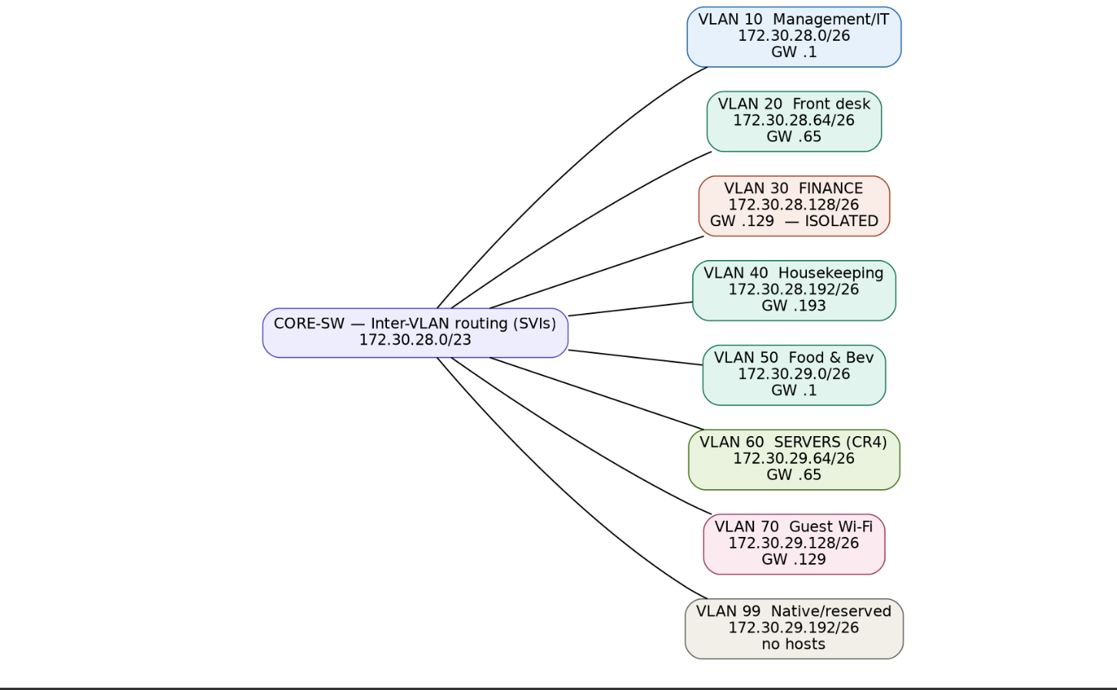

3.1 VLAN design
VLAN | Name | Purpose | Access policy
10 | MGMT | Management / IT | Full access; administrative exception to Finance and Servers
20 | FRONTDESK | Reception and reservations | General access plus Servers (authorised under CR4)
30 | FINANCE | Finance department | Isolated; reachable only from Management
40 | HOUSEKEEPING | Room status terminals | General access only
50 | FOODBEV | Restaurant and kitchen POS | General access only
60 | SERVERS | CR4 application/file server | Reachable only from VLAN 10 and VLAN 20
70 | GUESTWIFI | Guest wireless | Internet only; denied to all internal VLANs
99 | NATIVE | Native VLAN on trunks | Reserved; no hosts assigned
  - Routing
The first usable address of each subnet serves as the default gateway for inter-VLAN routing, which is carried out at the core switch utilizing one switched virtual interface per VLAN. The edge router contains a return route for 172.30.28.0/23, and a static default route points to it. Because the network is limited and only has one link to the internet, routing is purposefully kept static. A dynamic routing system would increase complexity without offering any advantages.
  - Access control design
ACL | Applied to | Effect
FINANCE-IN | Inbound on VLAN 30 | Permits Finance to reach Management and the internet; denies Finance to all other internal VLANs.
GENERAL-IN | Inbound on VLANs 20, 40, 50 | Denies all general users to the Finance subnet; permits only Front desk to the Servers subnet and denies the rest (CR4); permits all other traffic.
GUEST-IN | Inbound on VLAN 70 | Denies guests to the whole 172.30.28.0/23 internal range; permits internet-bound traffic only.
The restriction is applied both ways. Traffic coming from Finance is blocked by FINANCE-IN, whereas traffic going to Finance is blocked by GENERAL-IN. Return traffic would continue to flow if only one of the two were applied, which is a frequent flaw in this type of architecture and will be specifically verified.
- IP addressing plan
The allotted block 172.30.28.0/23 offers 512 addresses. Eight equal /26 subnets with 62 useable hosts each are created using the subnet mask 255.255.255.192. Since no department in a boutique hotel this size reaches 62 hosts, equal-sized subnets are utilized instead of variable-length subnetting since a uniform scheme is easier to describe, troubleshoot, and expand.
VLAN | Department | Subnet | Usable range | Gateway | Broadcast
10 | Management / IT | 172.30.28.0/26 | 172.30.28.1 – .62 | 172.30.28.1 | 172.30.28.63
20 | Front desk | 172.30.28.64/26 | 172.30.28.65 – .126 | 172.30.28.65 | 172.30.28.127
30 | Finance | 172.30.28.128/26 | 172.30.28.129 – .190 | 172.30.28.129 | 172.30.28.191
40 | Housekeeping | 172.30.28.192/26 | 172.30.28.193 – .254 | 172.30.28.193 | 172.30.28.255
50 | Food & beverage | 172.30.29.0/26 | 172.30.29.1 – .62 | 172.30.29.1 | 172.30.29.63
60 | Servers (CR4) | 172.30.29.64/26 | 172.30.29.65 – .126 | 172.30.29.65 | 172.30.29.127
70 | Guest Wi-Fi | 172.30.29.128/26 | 172.30.29.129 – .190 | 172.30.29.129 | 172.30.29.191
99 | Native / reserved | 172.30.29.192/26 | 172.30.29.193 – .254 | — | 172.30.29.255
4.1 Address assignment notes
•VLAN 10: CORE-SW routed link is where switch management addresses are obtained.194, ACCESS-SW-A.4, ACCESS-SW-B.5, ACCESS-SW-C.6, DIST-SW1 172.30.28.2, DIST-SW2 172.30.28.3.
•For access control lists to refer to a fixed host, the application/file server is statically addressed at 172.30.29.66.
•172.30.29.192/30, which is taken from the reserved VLAN 99 range, is used for the core-to-router link: EDGE-RTR 172.30.29.193, CORE-SW 172.30.29.194.
•VLAN hopping attacks that take advantage of the default native VLAN 1 are lessened because VLAN 99 is set up as the native VLAN on each trunk and carries no hosts.
•Static addressing is used by Finance, Servers, and Management, while DHCP scopes on the core switch may provide host addressing for common user VLANs.
https://github.com/mashaokeabetswebeyonce-creator/Computer-Networks-CMPG325-Project.git

